# Meeting Planner

Meeting planner is a simple project to show all meeting rooms and meeting location in different UI pages. To build UI used Django web framework and python. Added master page and simple css files to apply colouring to body section.

## Django running screenshot

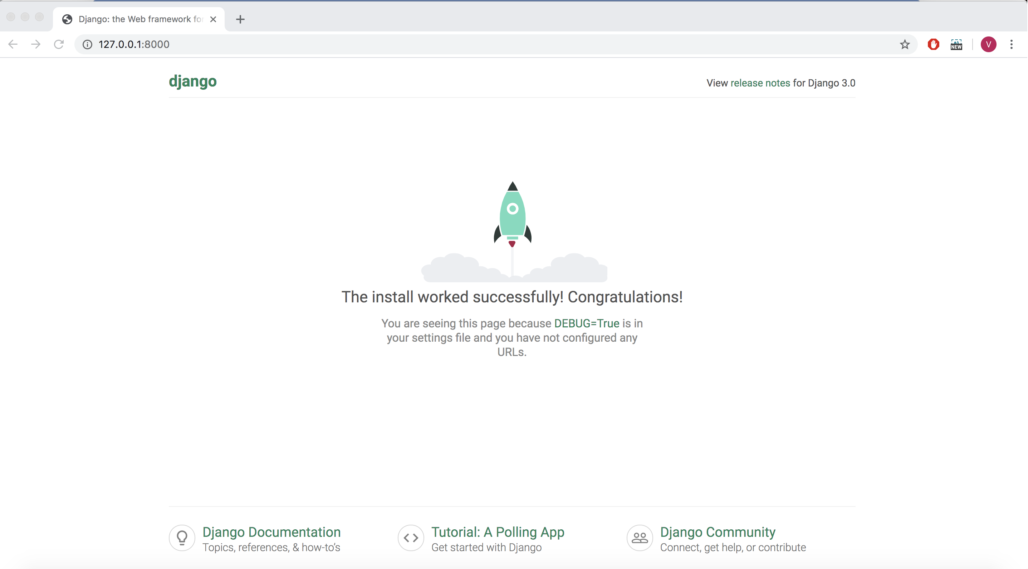

## Tables: Meeting, Room

Meeting table has foreignkey relation with Room table

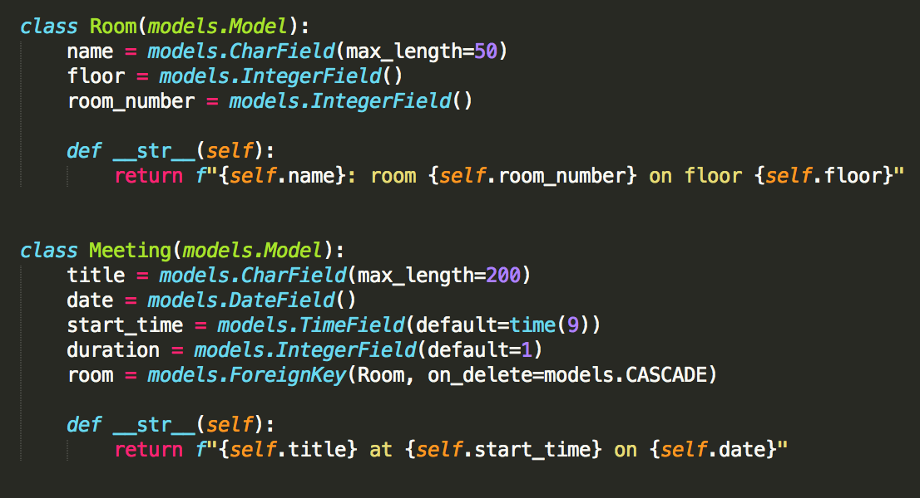

## Admin interface to add meeting

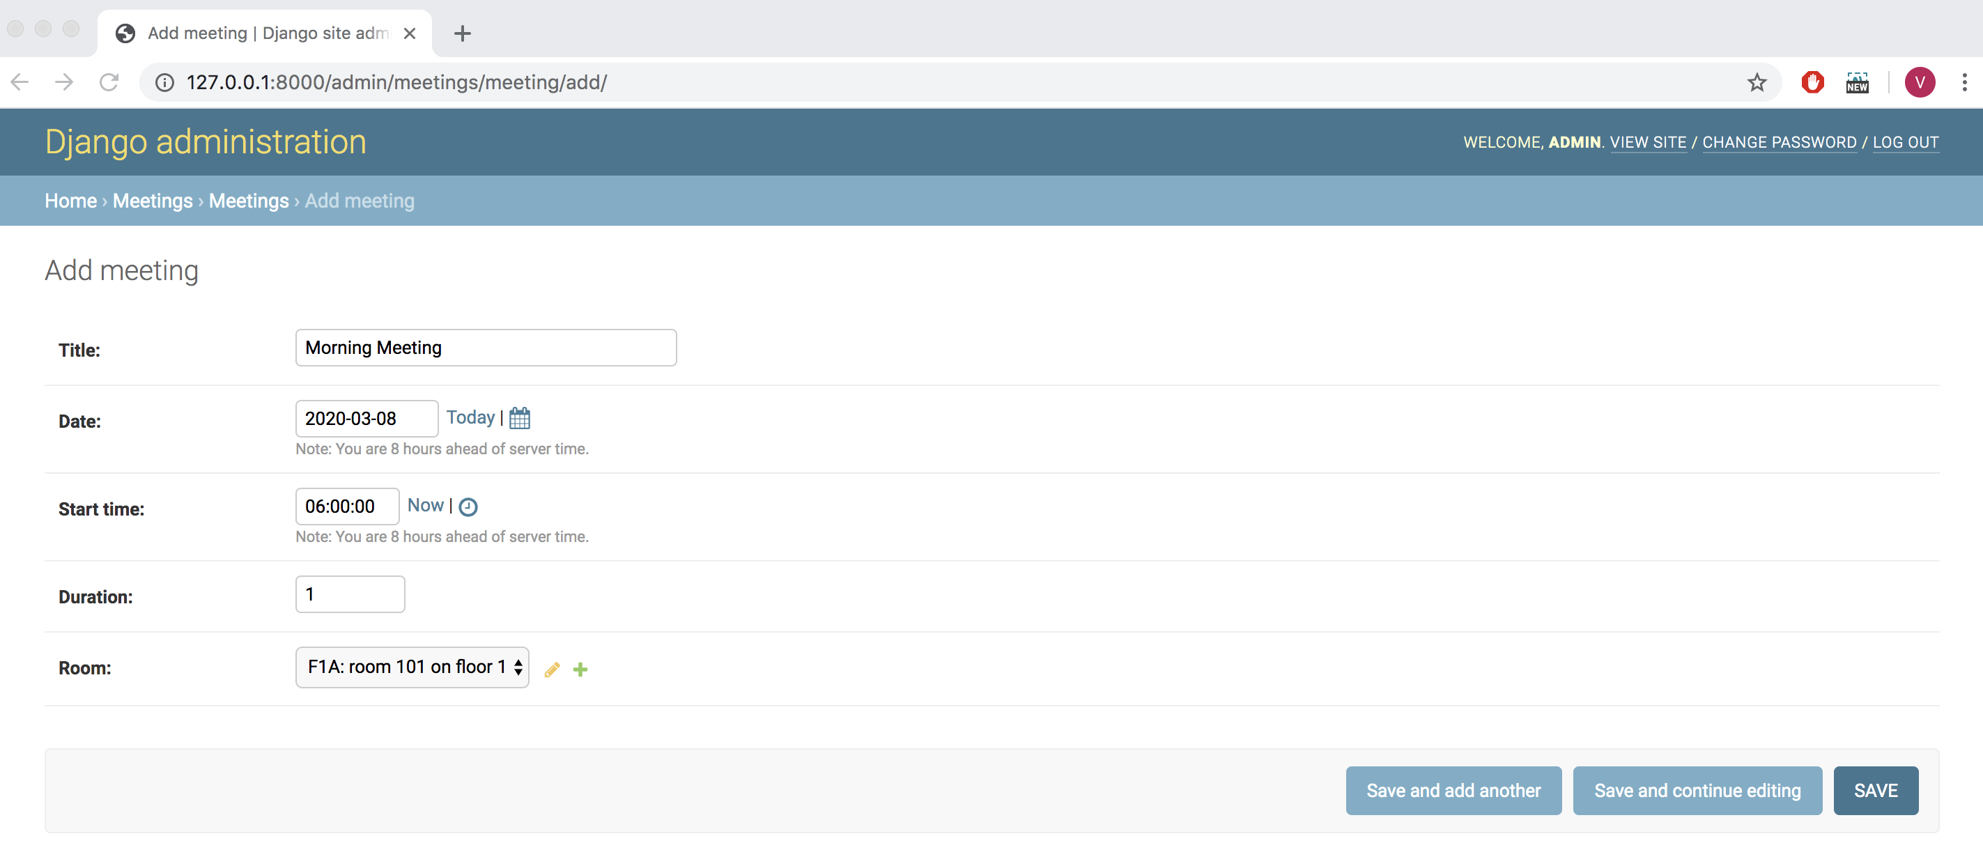

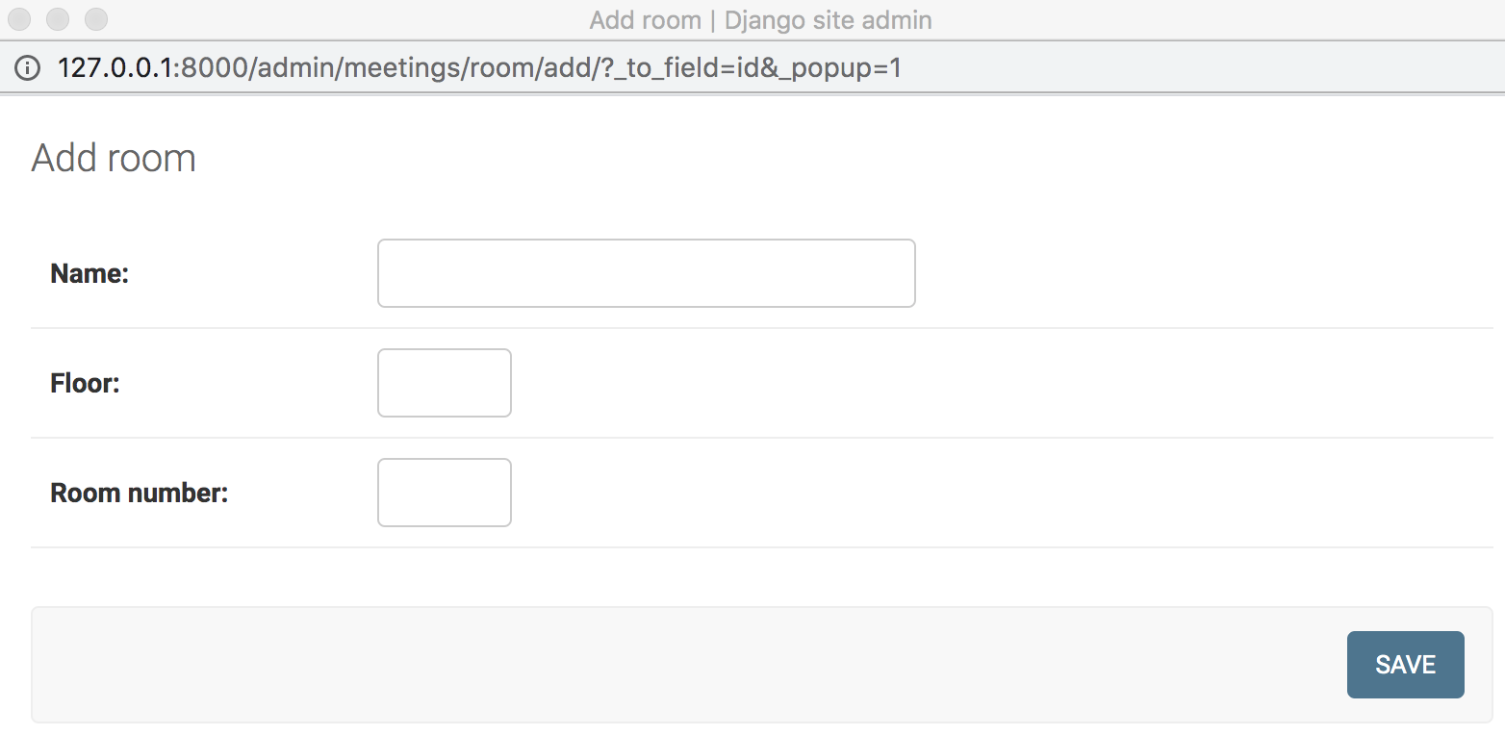

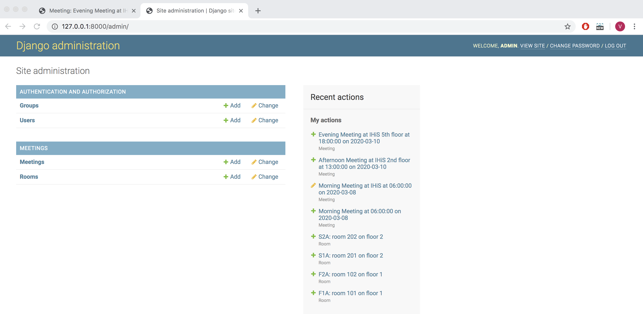

## UI to show rooms

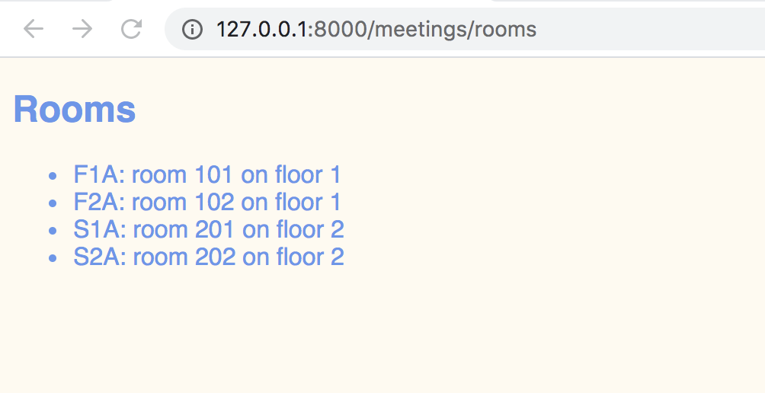

## UI to show meeting

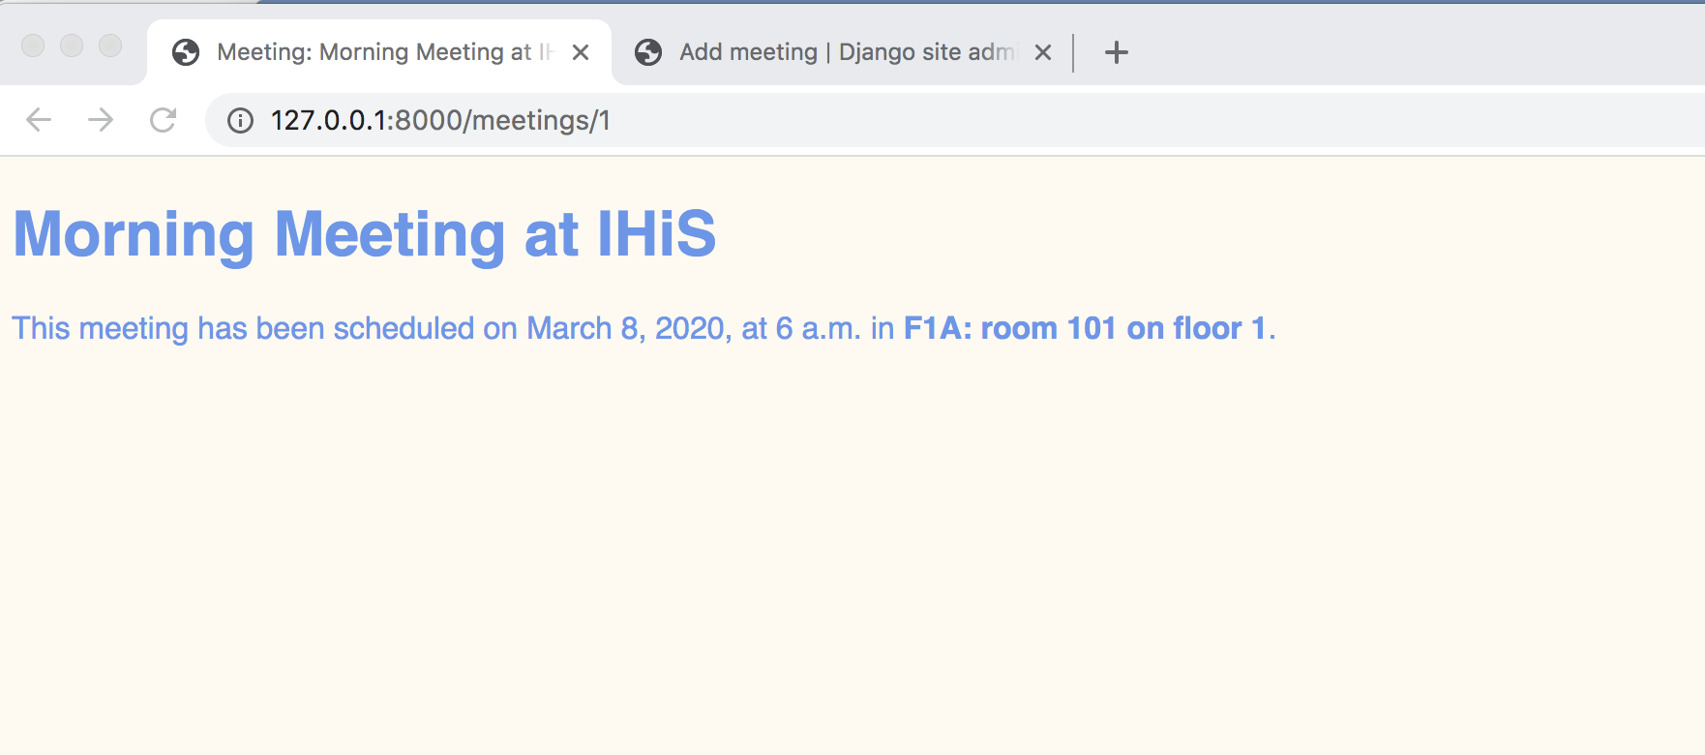

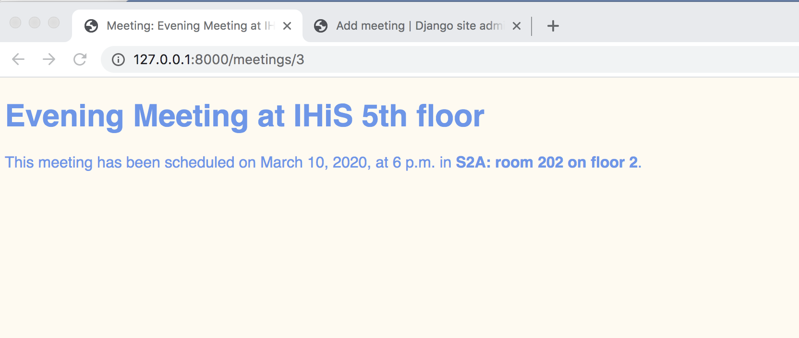

## Project structure

